2015-2016
Imagine Prep
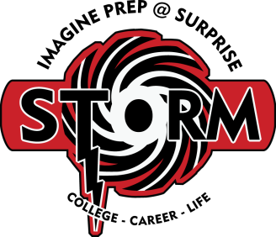
Swimming Roster
Autumn Froitland
Devon Schradle
Andorra Blattner
Ethan Thomas
DJ Seely
Chandler Holland
Sara Swanson
Tanaeah Singh
Aubrey Nelson
TJ Jones
Jonathon Gannon
Taylor Lancaster

